MEDZAH Medical Product Ordering & Customer Portal
B2B E Commerce | Medical Products | Customer Portal | Orders | Shopping Lists | Checkout

Project Overview
MEDZAH is a web based customer portal for medical product suppliers, allowing business customers to browse products, configure product options, place orders, manage shopping lists, track orders, and maintain their account information.

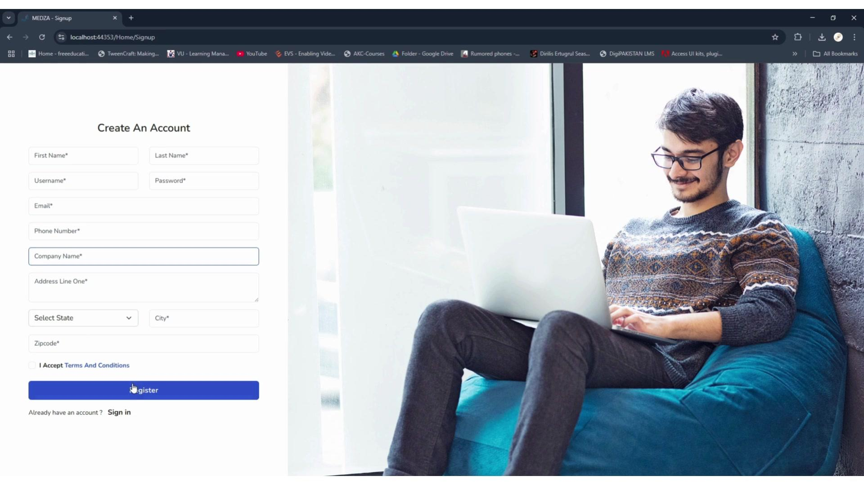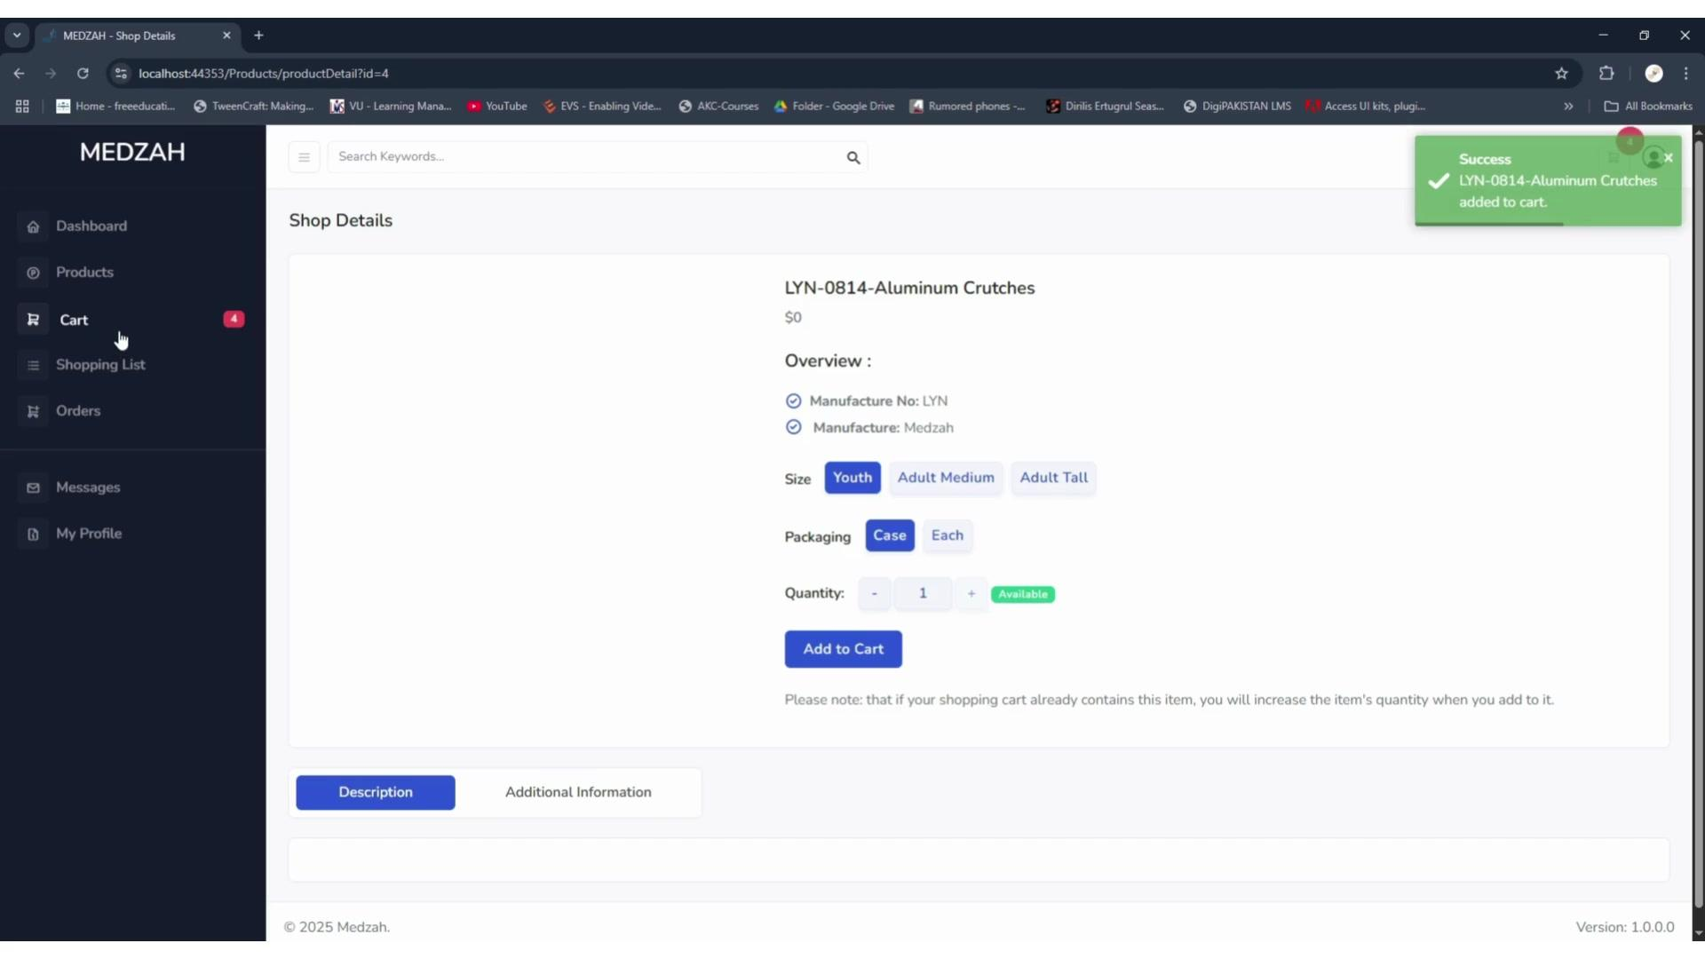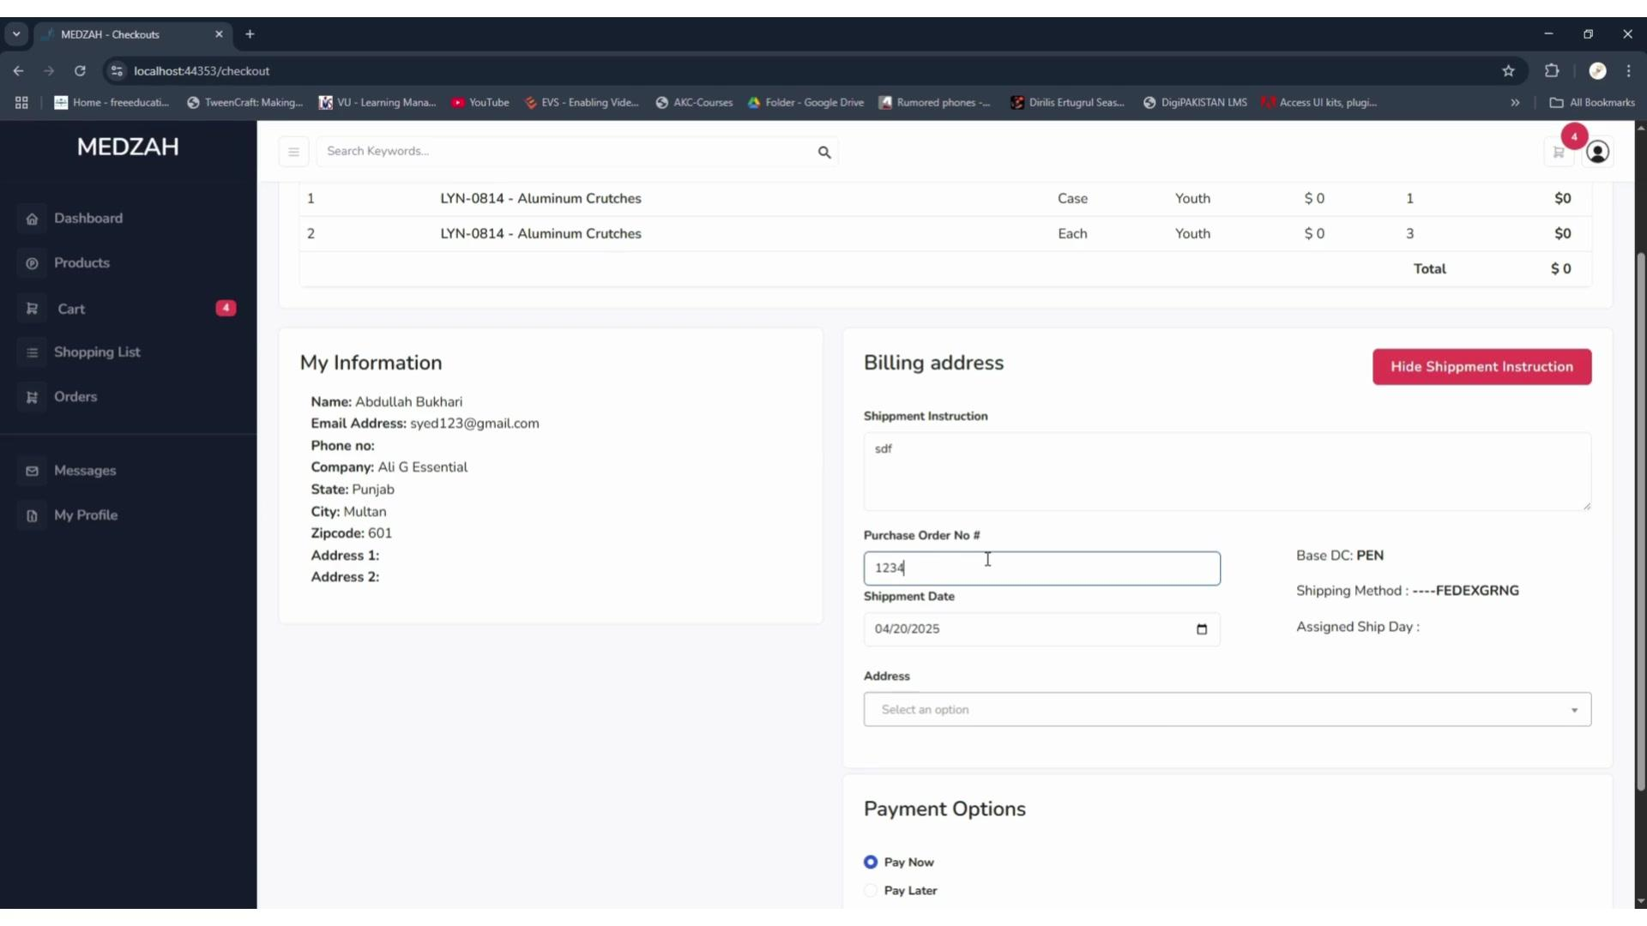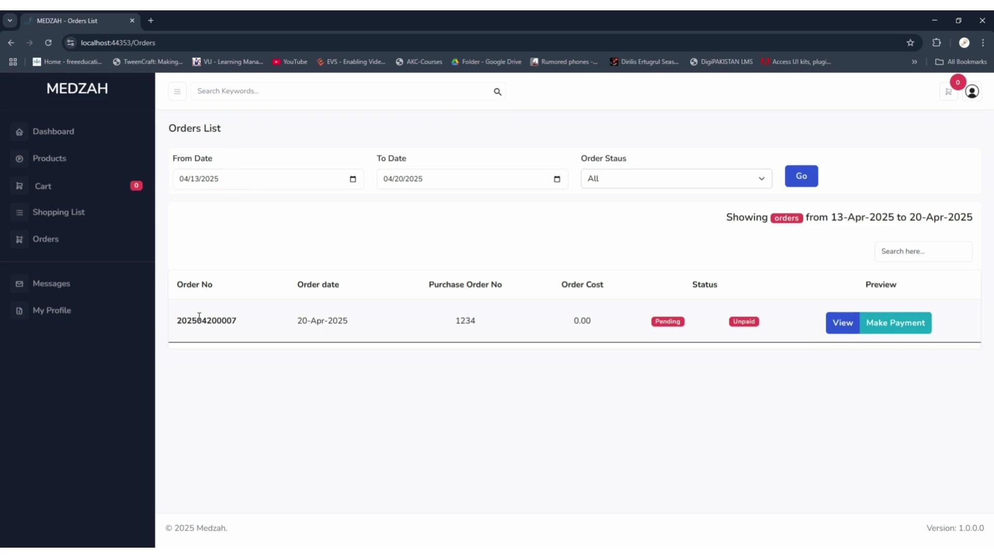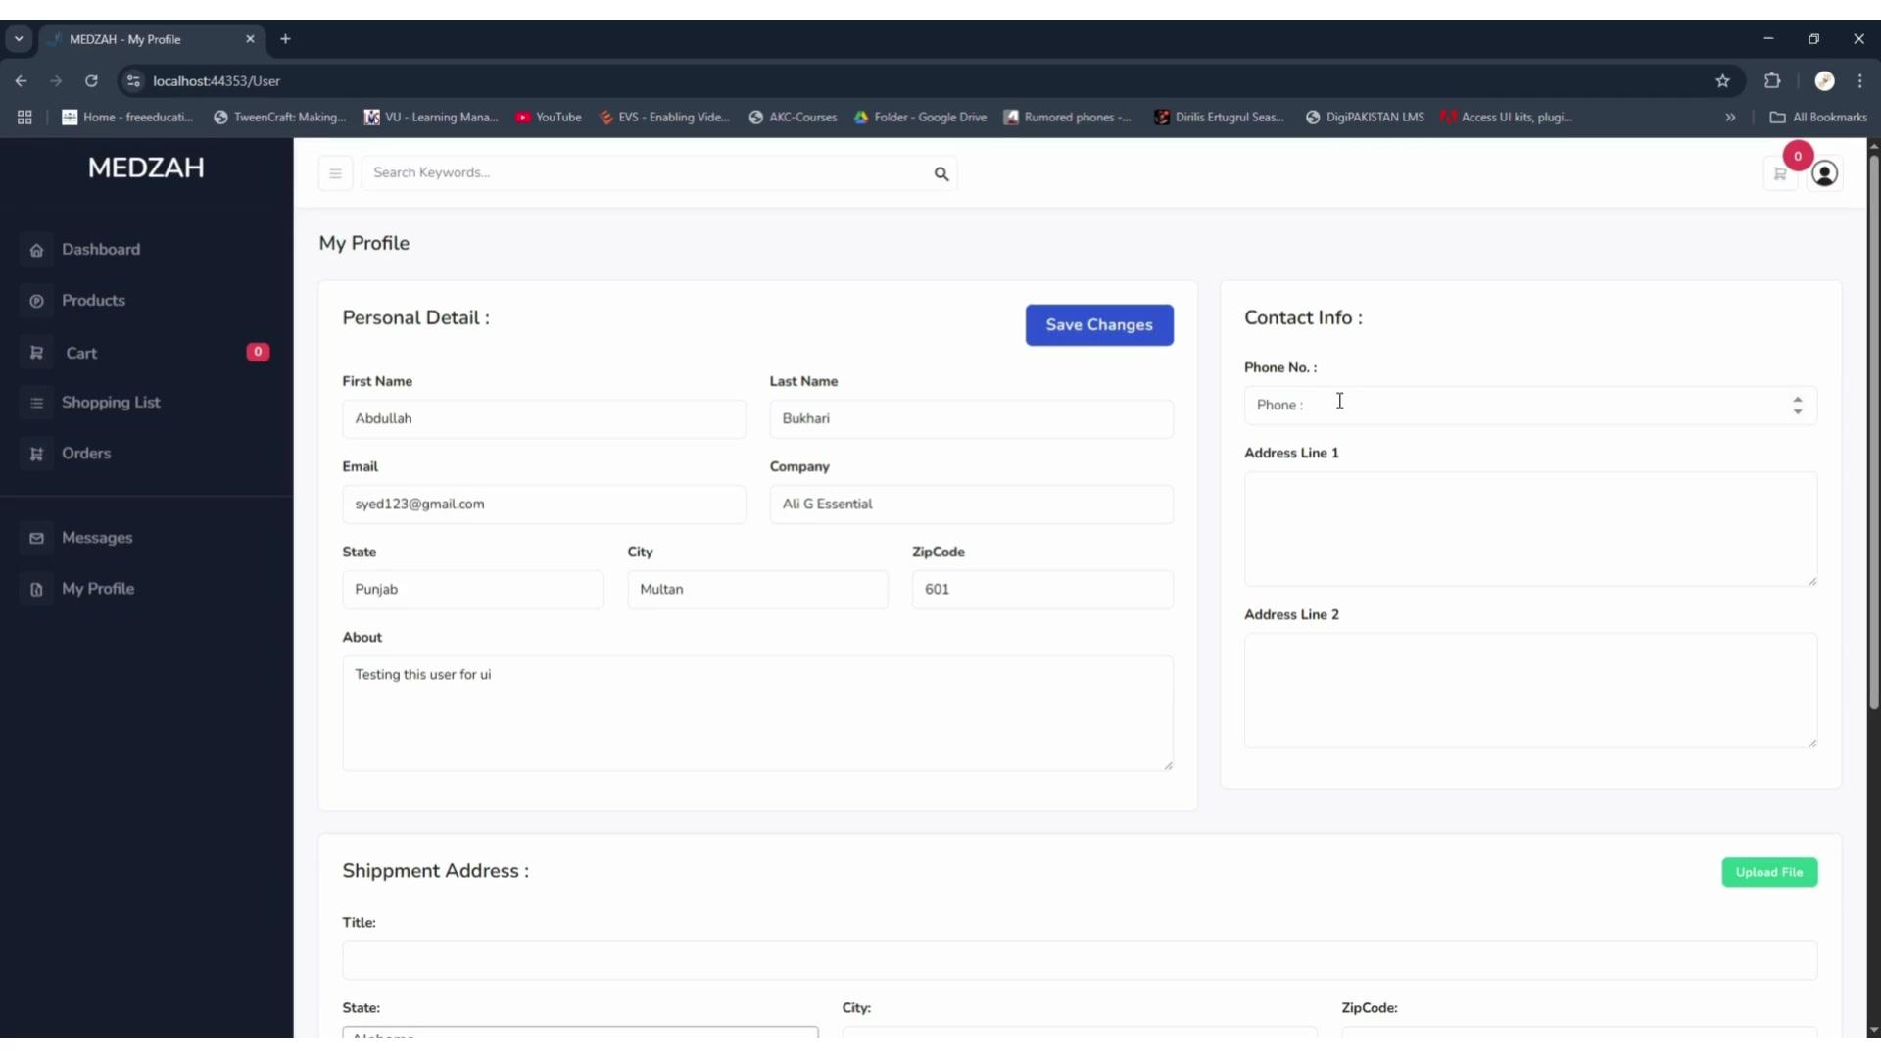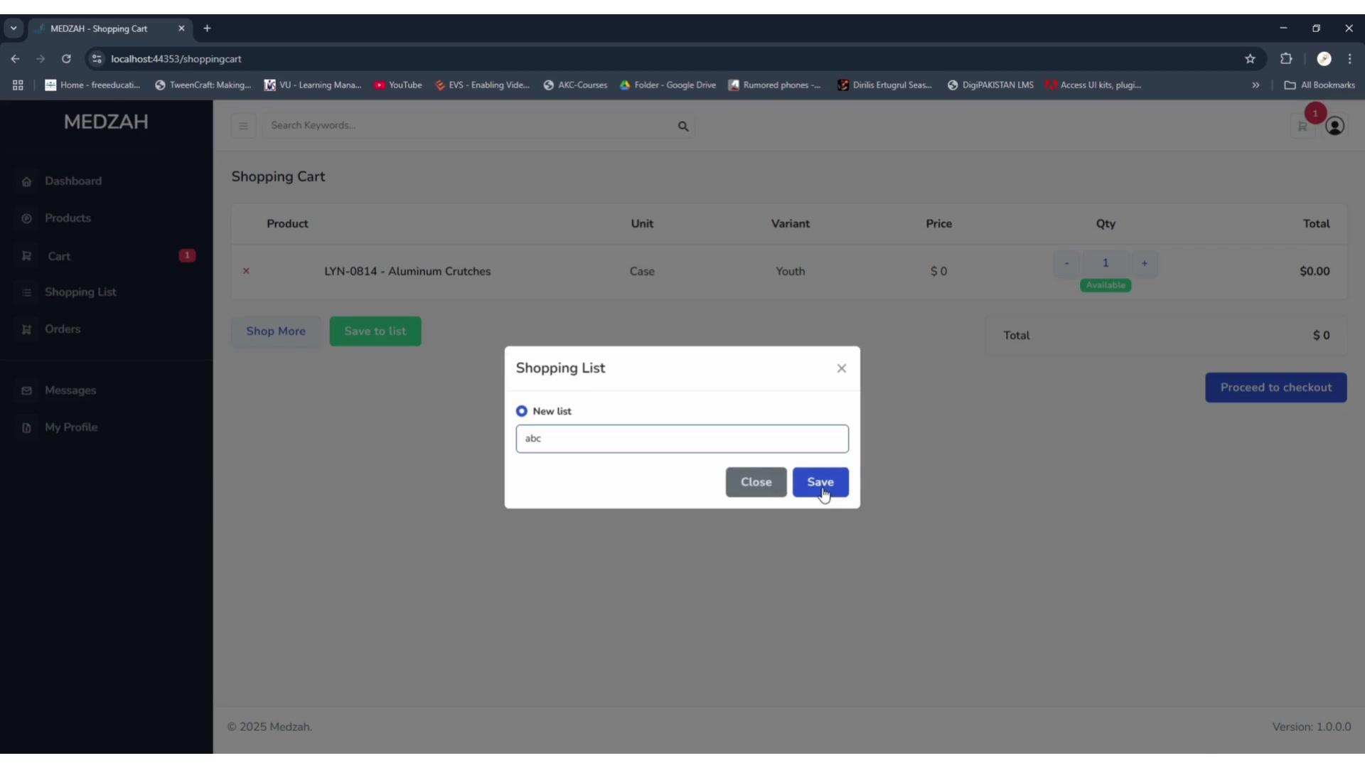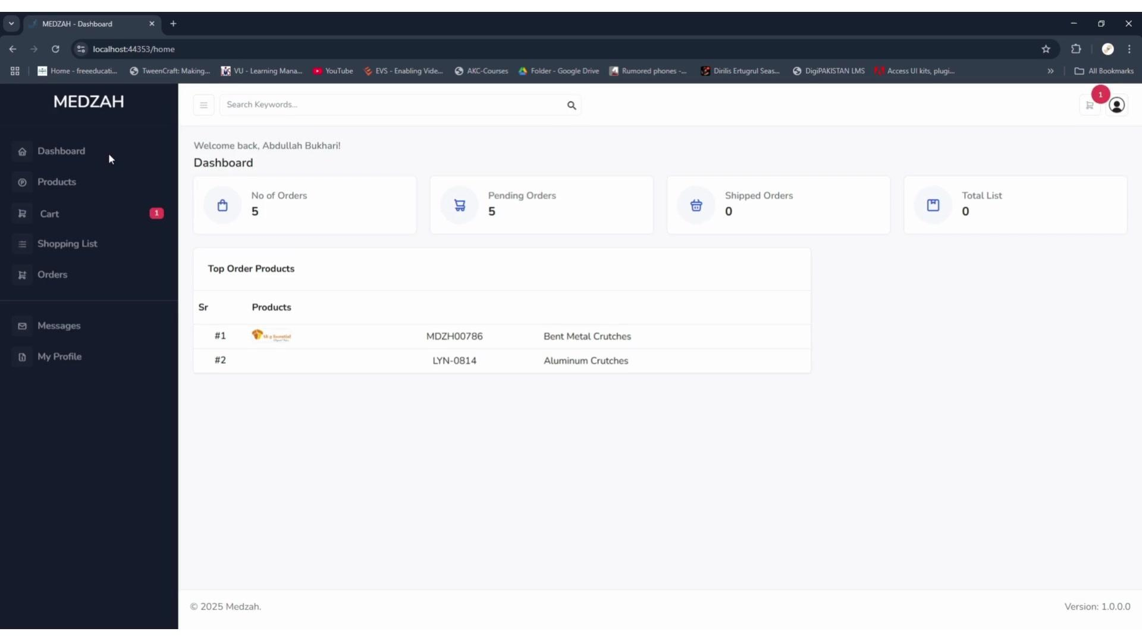

Main Modules
• Customer Registration
• Dashboard
• Products
• Shopping Cart
• Shopping Lists
• Checkout
• Orders
• Messages
• My Profile

Product Management
Customers can browse medical products and configure their purchases before adding them to the cart.
• Product details and pricing
• Manufacturer information
• Size and variant selection
• Packaging options
• Quantity management
• Product availability
• Add to Cart

Shopping Cart & Lists
The cart provides a complete overview of selected products, including:
• Product
• Unit
• Variant
• Price
• Quantity
• Total
Customers can also save products to named shopping lists, making repeat purchasing easier.

Checkout
The checkout process supports business purchasing requirements such as:
• Customer information
• Purchase Order Number
• Shipment instructions
• Shipment date
• Shipping address
• Shipping method
• Distribution center information
• Pay Now and Pay Later options
Checkout Flow:
Products → Configure Item → Cart → Checkout → Shipping Details → Payment → Order

Order Management
Customers can view and manage their orders through a dedicated order portal.
• Order history
• Date filtering
• Status filtering
• Order search
• Purchase order references
• Order cost
• Payment status
• Order preview
• Make Payment

Customer Profile
Customers can manage their own account information, including:
• Personal details
• Company information
• Contact information
• Billing information
• Shipment addresses
• Additional profile information

Dashboard
The dashboard provides a quick overview of customer activity:
• Total orders
• Pending orders
• Shipped orders
• Shopping lists
• Top ordered products

Business Value
The portal provides a self service purchasing experience for business customers, reducing manual order handling while making product selection, repeat purchasing, checkout, shipment information, and order tracking easier to manage.

Result
MEDZAH brings medical product browsing, product configuration, shopping lists, checkout, purchasing, order tracking, and customer account management into one centralized B2B portal.

